موضوع تحقیق : چند سوال تاریخ : 01/08/1404
استاد راهنما : دکتر سجاد فرخی
گرد آورنده : علیرضا کاروی
بررسی بهنیه بودن محسابه در تبدیل فوریه برای فیلترگذاری اسلاید 116-118
………………………………………………………………………………………………………………………………………………………………………………………………………………………………………………………………………………………………………………………………………………………………………………………………………………………………………………………………………………………………………………………………………………………………………………………………………………………………………………………………………………………………………………………………………………………………………………………………………………………………………………………………………………………………………………………………………………………………………………………………………………………………………………………………………………………………………………………………………………………………………………………………………………………………………………………………………………………………………………………………………………………………………………………………………………………………………………………………………………………………………………………………………………………………………………………………………………………………………………………………………………………………………………………………………………
…………………………………………………………………………………………………………

بررسی نتیجه متلب تست 6

M=50;
N=50;
[U,V]=dftuv(M,N);
D=hypot(U,V);% Euclidean distance

D=fftshift(D);

D0=5;

LP=(D<D0);% Logical Array
LP=double(LP);% Change the class to double
%LP=lpfilter('ideal',M,N,D0);
%% Show Filter
set(gcf,'units','normalized','outerposition',[0 0 1 1])
mesh(LP),axis tight,colormap('gray'),axis off
title(['Ideal lowpass filter \it D_0 =' num2str(D0)]);
view(-30,40)
%imshow(LP)
………………………………………………………………………………………………………………………………………………………………………………………………………………………………………………………………………………………………………………………………………………………………………………………………………………………………………………………………………………………………………………………………………………………………………………………………………………………………………………………………………………………………………………………………………………………………………………………………………………………………………………………………………………………………………………………………………………………………………………………………………………………………………………………………………………………………………………………………………………………………………………………………………………………………………………………………………………………………………………………………………………………………………………………………

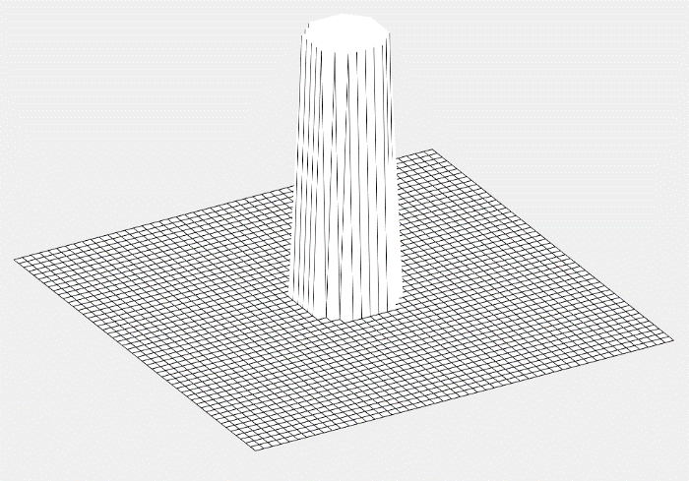
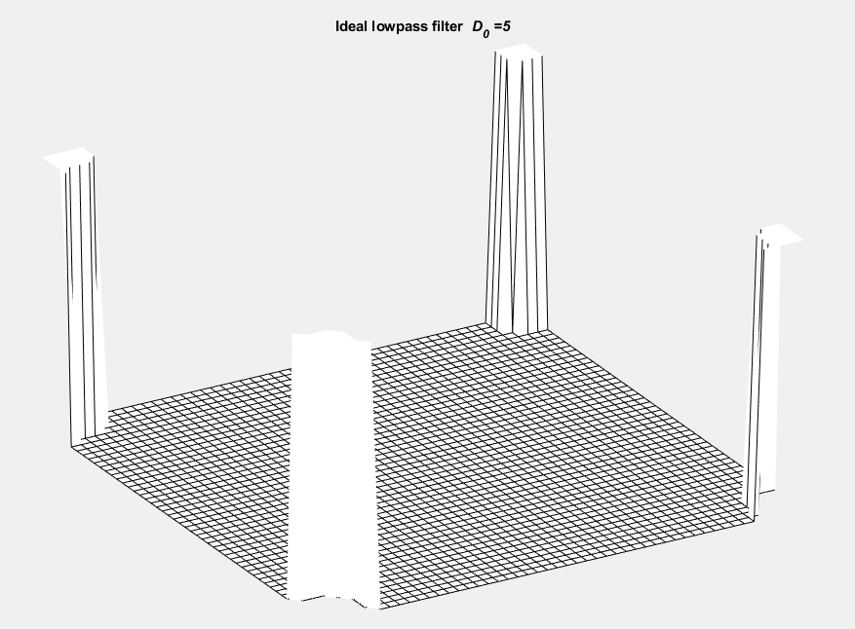
بررسی نتیجه متلب تست 7
%% Load Image
f=imread('circuit.tif');
f=im2double(f);
[m,n]=size(f);

%% FT
F=fft2(f,2*m,2*n);
[M,N]=size(F);

%% Generete Filter in Frequncy domain
D0=5;
H= lpfilter('ideal',M,N,D0);

%% Filtering
G=F.*H;

%% Change to Spatial Domain
g=ifft2(G);

%imshow(g,[])
g=g(1:m,1:n);% Remove Zeros

%% Show Results
set(gcf,'units','normalized','outerposition',[0 0 1 1])

subplot(1,2,1);imshow(f);title('Original image');
subplot(1,2,2);imshow(g);title(['Ideal lowpass filtering with \it D_0 =' num2str(D0)]);
…………………………………………………………………………………………………………………………………………………………………………………………………………………………………………………………………………………………………………………………………………………………………………………………………………………………………………………………………………………………………………………………………………………………………………………………………………………………………………………………………………………………………………………………………………………………………………………………………………………………………………………………………………………………………………………………………………………………………………………………………………………………………………………………………………………………………………
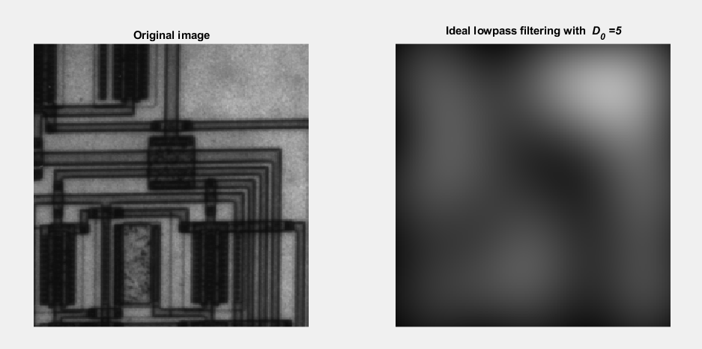

بررسی نتیجه متلب تست 8
clc
clear
close all

%% Load Image
f=imread('cameraman.tif');
f=im2double(f);
[m,n]=size(f);

%% FFT
F=fft2(f,2*m,2*n);
[M,N]=size(F);

%% Generete Filter in Frequncy domain
D0=50;
H= lpfilter('ideal',M,N,D0);

% Filtering
g = dftfilt2(F,H,m,n);

%% Show Results
set(gcf,'units','normalized','outerposition',[0 0 1 1])
subplot(1,2,1);imshow(f);title('Original image');
subplot(1,2,2);imshow(g);title(['Ideal lowpass filtering with \it D_0 =' num2str(D0)]);
………………………………………………………………………………………………………………………………………………………………………………………………………………………………………………………………………………………………………………………………………………………………………………………………………………………………………………………………………………………………………………………………………………………………………………………………………………………………………………………………………………………………………………………………………………………………………………………………………………………………………………………………………………………………………………………………………………………………………………………………

